Makro aflevering 2
- standard of living
- true
- true
- false
- true
- stock prices
- true
- true (since profits and dividends are strongly correlated, one could argue that this doesn’t directly impact but id still say its true)
- true
- true
- institutions
- false
- false
- true
- false
- true
tobins q is exactly $\frac{market cap}{book value}$
one could argue that
if investment goes down the demand for stocks go down thus market cap goes down
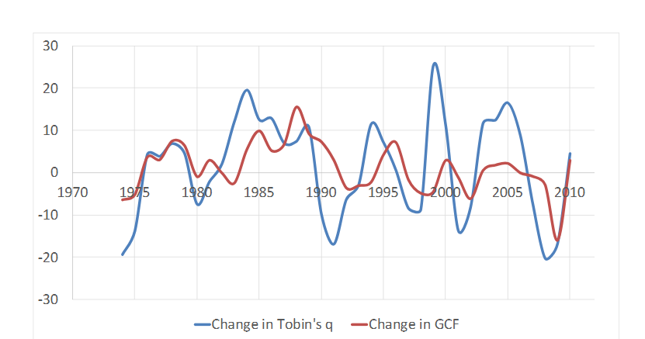
We see that roughly the two move in the same direction with tobins q being more volatile meaning that they are positively correlated

- true
in well developed countries there is an argument to be made that the increasing globalization and thus possibility to offshore low skill labor to cheaper markets as well as the increasing use of machines have decreased the overall demand for low skill labor. These new technologies is also the primary driving force in countries growth meaning that this is a necessary tradeoff if you wish for prolonged economic growth

- $Y=F\left(K,N\right)=4·\sqrt{K}·\sqrt{N}$
- Yes
$$F\left(T·K,T·N\right)=4·\sqrt{T·K}·\sqrt{T·N}=T·4·\sqrt{K}·\sqrt{N}=T·F\left(K,N\right)$$
- Yes
$$\frac{∂F}{∂K}=4·\sqrt{\frac{N}{K}}$$
$$\frac{∂^{2}F}{∂K^{2}}=-4·K^{-\frac{3}{2}}·N^{\frac{1}{2}}<0$$
- Steady state consumption and capital per worker
$$\frac{Y}{N}=\frac{F\left(K,N\right)}{N}=F\left(\frac{K}{N},1\right)=4·\sqrt{\frac{K}{N}}$$
In steady state we have
$$s·\frac{Y}{N}=δ·\frac{K}{N}$$
$$s·4·\sqrt{\frac{K}{N}}=δ\frac{K}{N}⇔4·\frac{s}{δ}=\sqrt{\frac{K}{N}}⇔\frac{K}{N}=16·\frac{s^{2}}{δ^{2}}$$
$$\frac{Y}{N}=4·\sqrt{\frac{K}{N}}=16·\frac{s}{δ}$$
- The golden rule level of capital is the level of capital accumulation which maximizes consumption and thus wellbeing of citizens
$$\frac{c}{N}=\left(1-s\right)·\frac{Y}{N}$$
$$\max_{s}{\frac{c}{N}}$$
$$\left(1-s\right)·\frac{Y}{N}=\left(1-s\right)·16·\frac{s}{δ}$$
$$\frac{∂\frac{c}{N}}{∂s}=\frac{16}{δ}-\frac{32s}{δ}=0⇔s=\frac{1}{2}$$
- It depends on the goals of the government since a convergens towards the stady state is rather slow if you asked a population to decrease their consumption to try and reach the golden rule level of consumption they ould have to decrease their consumption to have an increase later this would most certainly be an unpopular political move but would most certainly improve consumption in time
- 2
- $\frac{I}{AN}=s·\frac{Y}{AN}=(δ+g_{N}+g_{a})\frac{K}{AN}$
- Under this equation the output per effective worker stays constant
Growth of $\frac{Y}{N}=g_{A}$
Under the constaint of fixed $\frac{Y}{AN}$ then if A increases then $\frac{Y}{N}$ must also increase for it to be fixed “the only way of prolonged growth is through either population growth or technological growth” and when we look at $\frac{Y}{N}$ thus the only remaining parameter must be
- picture
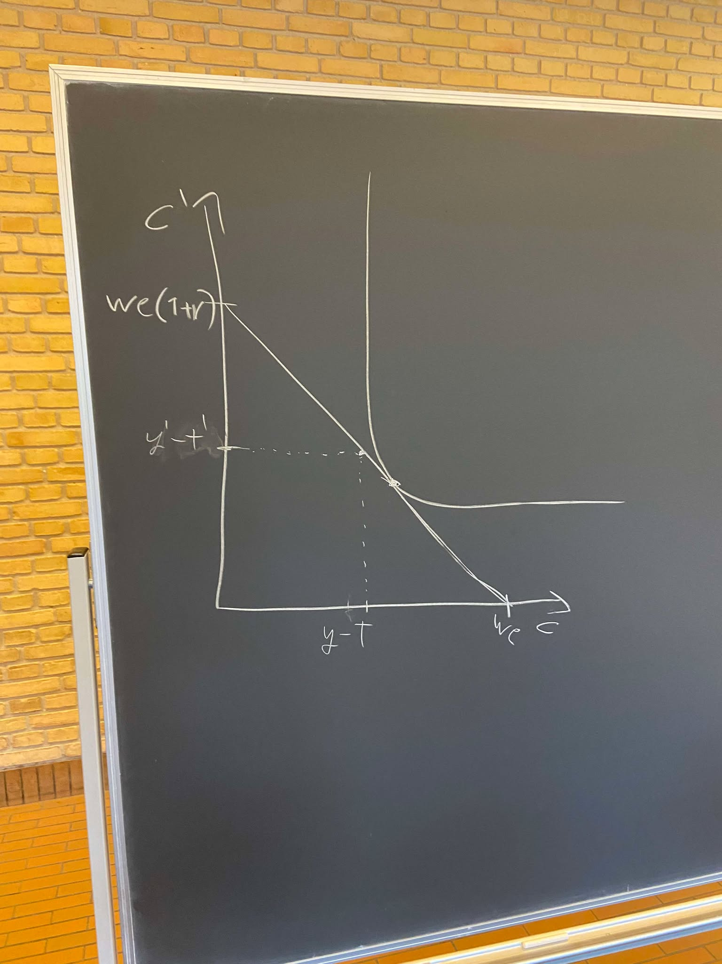
Since $c>y-t$ then the consumer must be borrowing the difference

- Negative population growth
$$I=S=Y·s=\left(δ+g_{N}+g_{A}\right)·K>0⇔\left(δ+g_{N}+g_{A}\right)>0$$
Thus the magnitude of Japans population decline must be lower than the the magnitude of $δ+g_{N}$

- Nyt steady state på billede
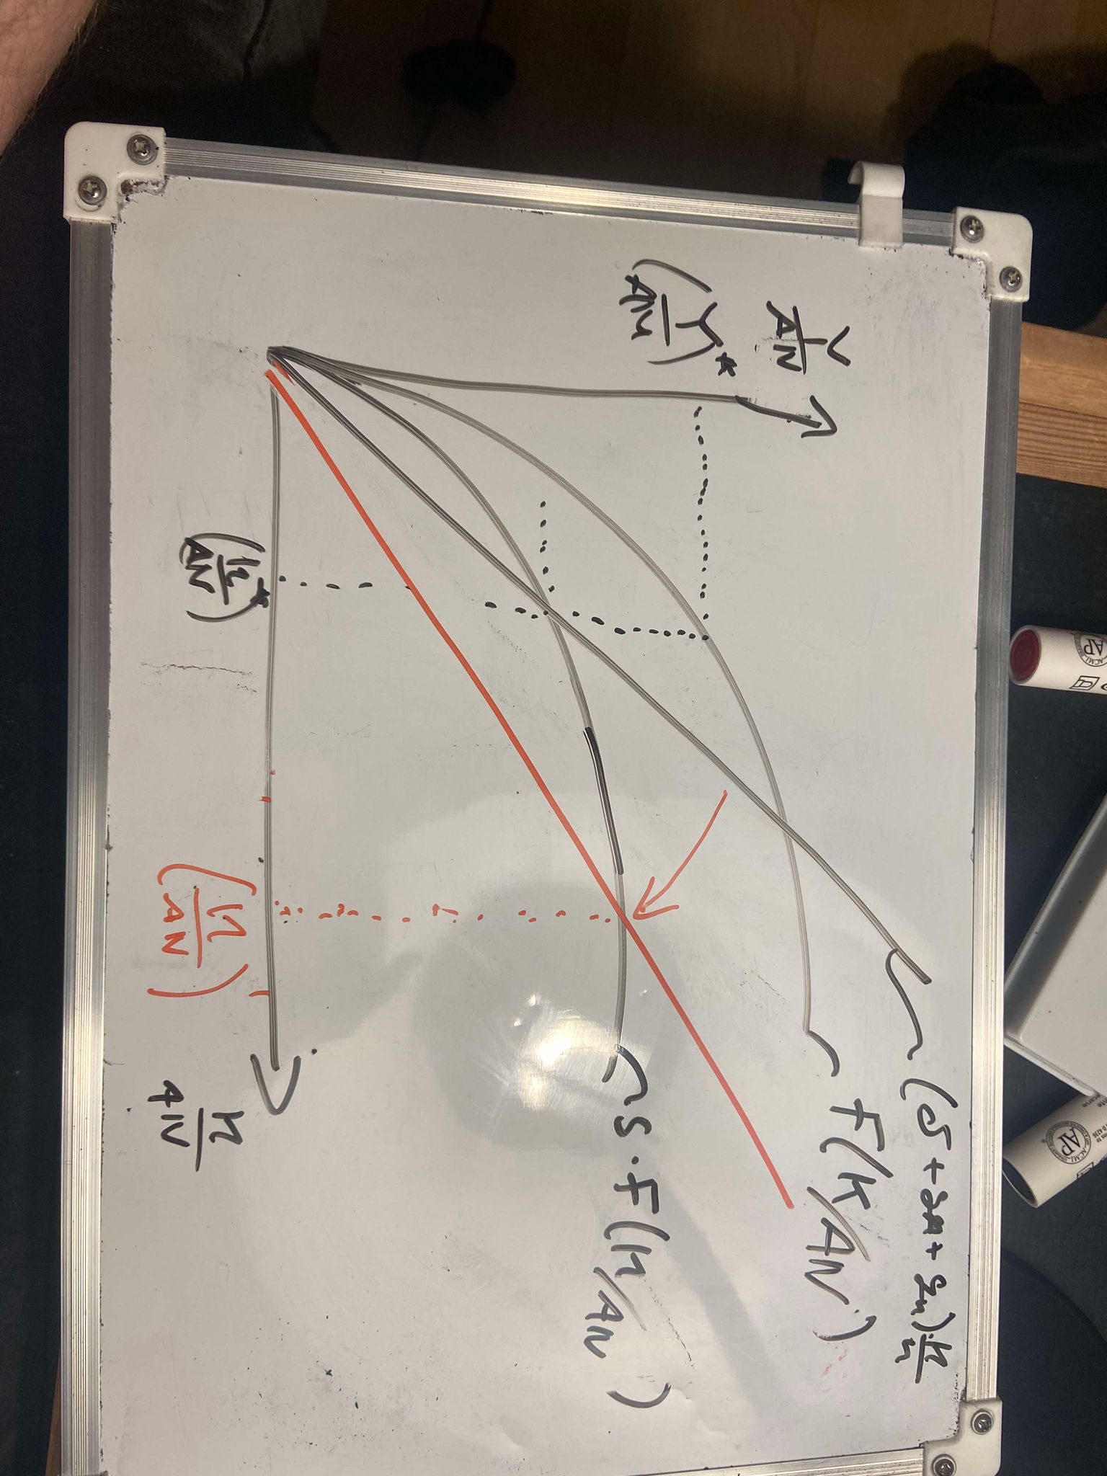
Since there are less people to share tha accumulated capital each worker has more kapital at their disposal
- Log output as a function of time
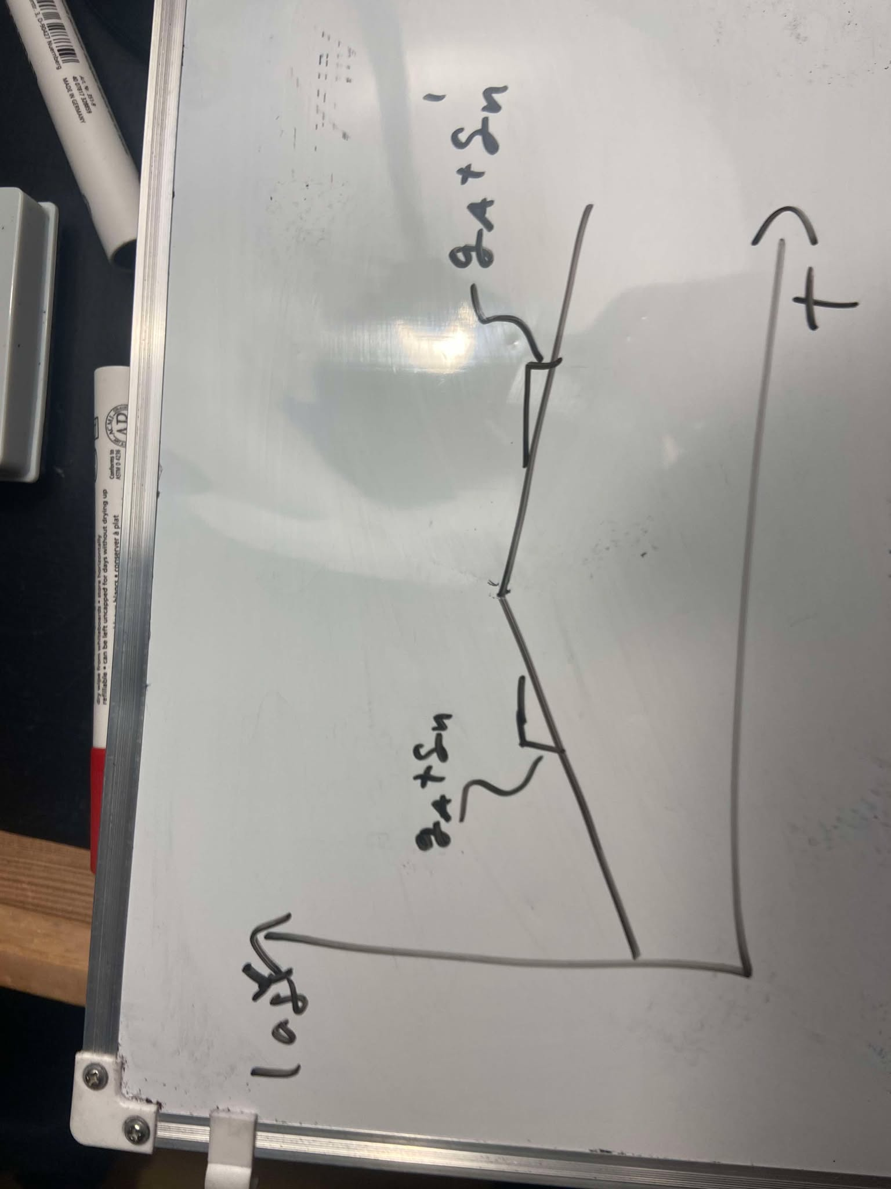
E only assumed that $\left(δ+g_{N}+g_{A}\right)>0$
We could still have that $g_{N}+g_{A}<0$
- How should the transition look?
Ive drawn It as sharp but it should probably be a smooth curve since population growth doesn’t just drastically change overnight
- Compare new and old stady states
In the new steady state we have higher output per worker which we have previously stated as a way to measure standard of living this comes at a cost of lower total output growth meaning if your goal is to maximize output over time Japan ould be in a worse spot if its population is declining
- 2
- Risk premium
Bond holders are exposed to more risk given a longer duration of the bond given the equation
$$i_{0,t}=\sqrt[t]{(1+i_{0,1})\prod_{t=1}^{n-1}{(1+i_{t,t+1}^{e}+x)}}-1$$
Where x is the premium demand for holding the risk of changing interest rates being able to devalue your bond
B
The gap has decreased because yields is expected to decline as feds cut rates
When short term interest rates dercrease it affects the shorter term bonds moe than longer term bond as(in the 2 period example)
$${\left(1+i_{0,2}\right)}^{2}=\left(1+i_{0,1}\right)\left(1+i_{1,2}\right)⇒i_{0,2}≈\frac{1}{2}(i_{0,1}+i_{1,2})$$
When $i_{0,1}$ decreases $i_{0,2}$ will only decrease by half, this is of course assuming that the change in $i_{1,2}$ is 0 but we still expect the rate in the long term to be more stable

C
Yes at the lectures we have argued that an inverted yield curve is a recession indicator
Inverted yield curve implies that the market expects rates to go down in the future usually because of poor economic performance

- 2
- We write up the consumption constraints which are binding
$$c+s=y-t$$
$$c^{'}=y^{'}-t^{'}+\left(1+r\right)·s⇔s=\frac{c^{'}-\left(y^{'}-t^{'}\right)}{1+r}$$
$$⇒c+\frac{c^{'}-\left(y^{'}-t^{'}\right)}{1+r}=y-t⇔c+\frac{c^{'}}{1+r}=y-t+\frac{y^{'}-t^{'}}{1+r}=we$$
- ”the usual properties” is exactly what lets us use the lagrangian method to optimize which is exactly what we are going to do also it lets us say that the utility of the period is given as
$$=u\left(c\right)+β·u\left(c^{'}\right)$$
Where $β$ is the personal discountfactor of consumption
Thus we have
$$\max{u\left(c\right)+β·u\left(c^{'}\right)}$$
$$s.t c+\frac{c^{'}}{1+r}=we$$
Use the lagrangian method
$$L=u\left(c\right)+β·u\left(c^{'}\right)-λ\left(c+\frac{c^{'}}{1+r}-we\right)$$
$$\frac{∂L}{∂c}=u^{'}\left(c\right)-λ=0⇔u^{'}\left(c\right)=λ$$
$$\frac{∂L}{∂c'}=βu^{'}\left(c'\right)-\frac{λ}{1+r}=0⇔βu^{'}\left(c^{'}\right)\left(1+r\right)=λ$$
$$\frac{∂L}{∂λ}=0⇔c+\frac{c^{'}}{1+r}=we$$
$$\left(1\right)+\left(2\right)⇒u^{'}\left(c\right)=u^{'}\left(c^{'}\right)·β\left(1+r\right)⇔\frac{u^{'}\left(c\right)}{u^{'}\left(c^{'}\right)}=β(1+r)$$
Which is exactly the euler equation
In the euler equation we can think of setting marginal gain equal to marginal cost where we value utility in period to a little different and if we save have a little more to use in period 2
We set marginal gain equal to marginal cost
- Picture
- We just derived it in the general term so we just use the formula above

$$u\left(c\right)=\log\left(c\right)$$
$$u^{'}\left(c\right)=\frac{1}{c}$$

$$u^{'}\left(c\right)=u^{'}\left(c^{'}\right)·β\left(1+r\right)$$
$$\frac{1}{c}=\frac{1}{c^{'}}·β·\left(1+r\right)⇔$$
Now we set into the intertemporal budget constraint
$$c+\frac{c^{'}}{1+r}=y-t+\frac{y^{'}-t^{'}}{1+r}$$
$$c+c·β=c\left(1+β\right)=y-t+\frac{y^{'}-t^{'}}{1+r}$$

$$c^{'}=β·\left(1+r\right)·\frac{1}{1+β}\left(y-t+\frac{y^{'}-t^{'}}{1+r}\right)=\frac{β}{1+β}\left((y-t)(1+r)+y^{'}-t^{'}\right)$$

- Now let y change by $Δy$
$$c_{1}=\frac{1}{1+β}\left(y+Δy-t+\frac{y^{'}+Δy-t^{'}}{1+r}\right)=\frac{Δy}{1+β}·\left(1+\frac{1}{1+r}\right)+c_{0}$$
$$c_{1}^{'}=\frac{β}{1+β}\left(\left(y+Δy-t\right)\left(1+r\right)+y^{'}+Δy-t^{'}\right)=\frac{β}{1+β}·Δy·\left(2+r\right)+c_{0}^{'}$$
$$Δc=\frac{Δy}{1+β}·\left(\frac{2+r}{1+r}\right)>Δy⇔\left(\frac{2+r}{1+r}\right)>1+β⇔\frac{1}{1+r}>β$$
$$Δc^{'}=\frac{β}{1+β}·Δy·\left(2+r\right)>Δy⇔\frac{β·\left(2+r\right)}{1+β}>1⇔2+r>\frac{1}{β}+1⇔β>\frac{1}{1+r}$$
These two inequality make great intuitive sense since i you value consumption in the next period higher than the discount rate youd rather spend more in the next period
Ie we must have marginal gain equals marginal cost

